
Mawlana Bhashani Science and Technology University
Sontosh, Tangail-1902
Department of Information and Communication Technology

Lab Report

Lab Report no : 02
Name of the report : Data types in MySQL.
Course title : Database Management System Lab
Course code : ICT-2110

Submitted By | Submitted To
Name: Monirojjaman Ayoive  ID: IT-23013  2nd Year, 1st Semester  Session: 2022-2023  Dept. of ICT, MBSTU | Dr. Md. Abir Hossain  Associate Professor  DEPARTMENT OF INFORMATION AND COMMUNICATION TECHNOLOGY  MAWLANA BHASHANI SCIENCE AND TECHNOLOGY UNIVERSITY
Date of Performance: 16-11-2024 Date of Submission: 23-11-2024

Experiment no: 02
Experiment name: Data types in MySQL.
Introduction:
A data type in MySQL defines all the data that could be storing into that column. The data types will optimize the space that gets consumed for proper validation and query processing. MySQL supports many types of data, they are:
- Numeric Data Types
- Date and Time Data Types
- String Data Types

Materials Required:
- MySQL Server (v.0 or later)
- MySQL Workbench or any preferred MySQL client
- SQL editor and access to a test database
Procedure :

Step 1: Exploring Numeric Data Types
- Connect to the MySQL server.
- Create a table to explore numeric data types
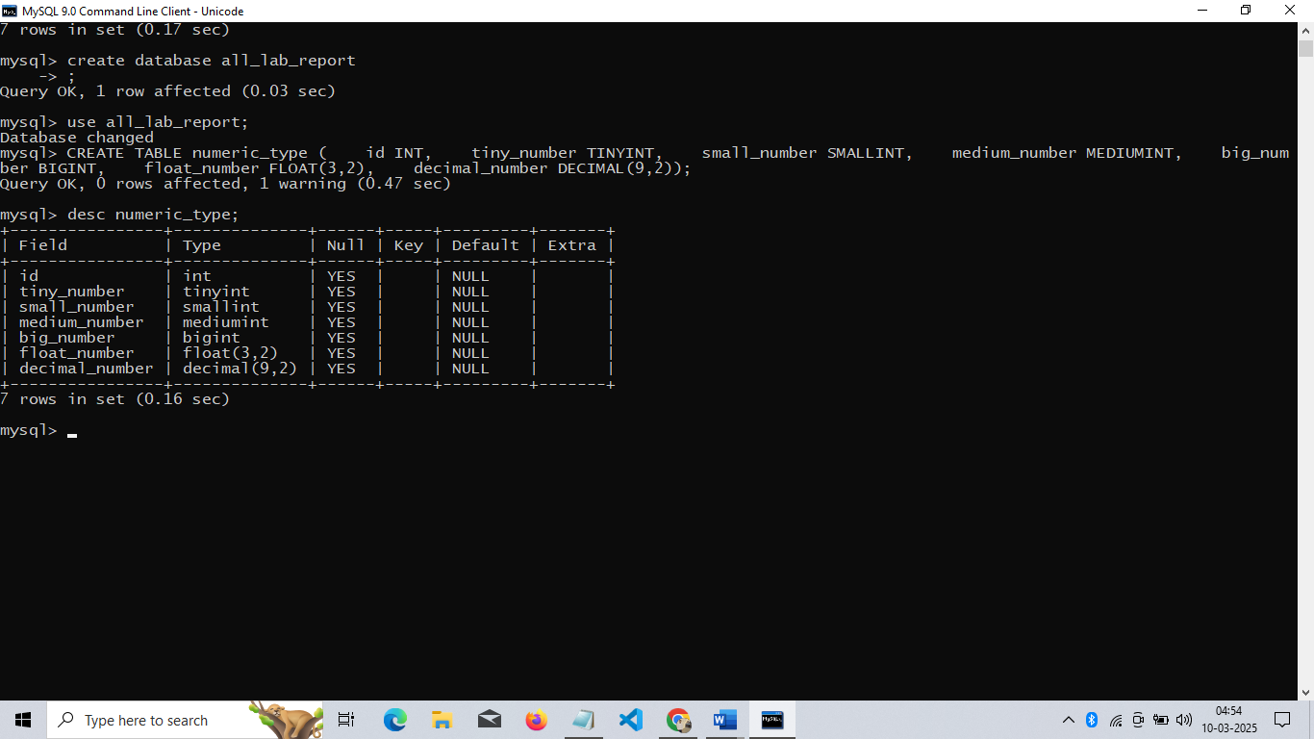
- Insert sample data to understand the range and size:
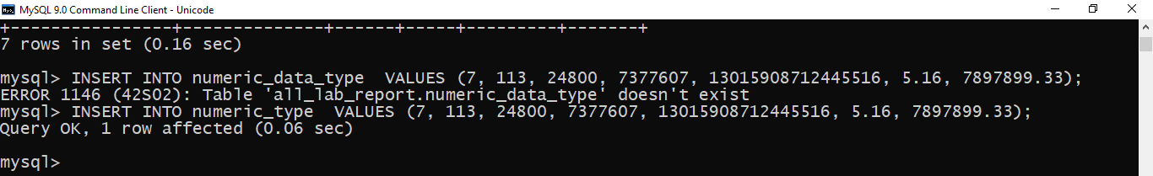
- Query the data and observe the behavior:

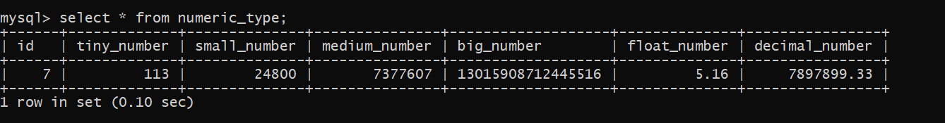

Number data types and range:
TINYINT ( ) | -128 to 127 normal | 0 to 255 UNSIGNED
SMALLINT( ) | -32768 to 32767 normal | 0 to 65535 UNSIGNED
MEDIUMINT( ) | -8388608 to 8388607 normal | 0 to 16777215 UNSIGNED
INT( ) | -2147483648 to 2147483647 normal | 0 to 4294967295 UNSIGNED
BIGINT( ) | -9223372036854775808 to 9223372036854775807 normal | 0 to 18446744073709551615 UNSIGNED
FLOAT | A small number with a floating decimal point.
DOUBLE( , ) | A large number with a floating decimal point.
DECIMAL( , ) | A DOUBLE stored as a string, allowing for a fixed decimal point.

Step 2: Exploring String Data Types
- Create a table to understand string data type
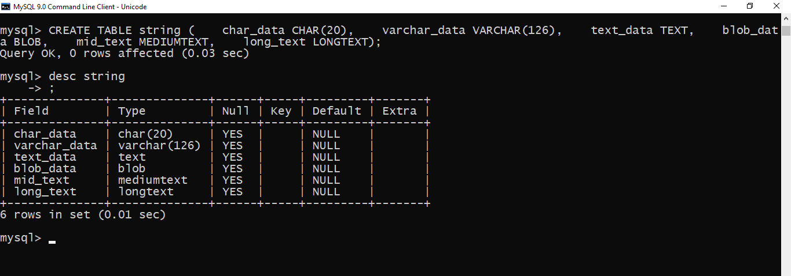
- Insert Sample data
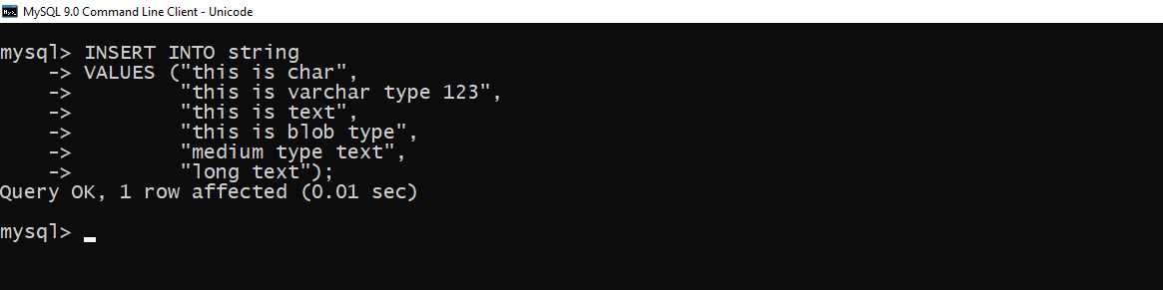
3. Query and analyze:
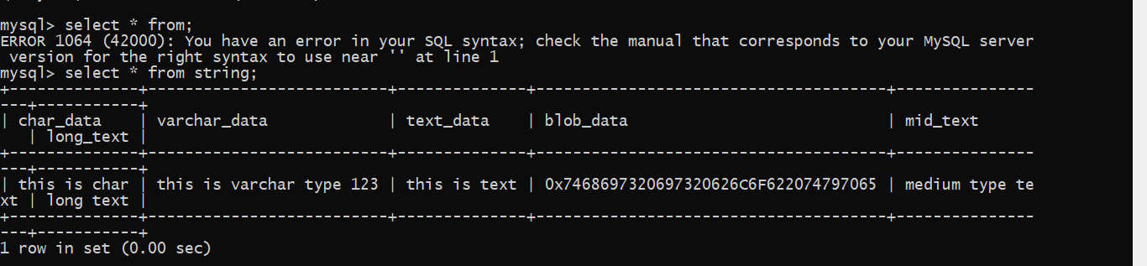

Text data types and range:
CHAR( ) | A fixed section from 0 to 300 characters long.
VARCHAR( ) | A variable section from 0 to 300 characters long.
TINYTEXT | A string with a maximum length of 300 characters.
TEXT | A string with a maximum length of 65535 characters.
BLOB | A string with a maximum length of 65535 characters.
MEDIUMTEXT | A string with a maximum length of 16777215 characters.
MEDIUMBLOB | A string with a maximum length of 16777215 characters.
LONGTEXT | A string with a maximum length of 4294967295 characters.
LONGBLOB | A string with a maximum length of 4294967295 characters.

Step 3: Exploring Date and Time Data Types
1.Create a table for date and time exploration:

2. Insert data into the table:

3. Query the data to observe output formats:

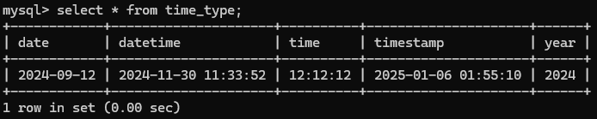

Date/Time data types and format:
DATE | YYYY-MM-DD
DATETIME | YYYY-MM-DD HH:MM:SS
TIMESTAMP | YYYYMMDDHHMMSS
TIME | HH:MM:SS
YEAR | YYYY

Conclusion:
Knowing the MySQL data types a person must have for making a highly efficient and effective schema under which the designed database can come. Also, it helps in the proper selection of data types by minimizing storage requirements, securing data integrity, and improving performance. Furthermore, during the laboratory activity, different defined data types were explored and understood in terms of their characteristics and practical applications.

